# **Introduction**

## Purpose

The product is an online platform that gives a chance for developers to build their careers and for startup companies to instigate their businesses giving a chance to beginning developers to build a portfolio and add on experience and for companies to get their projects done.

This is the first release of the website’s prototype, and this document covers the system features and how it is executed.

## Executive Summary

This website is an online platform for those who are looking to start their careers

whether as a developer/freelancer or someone looking to make their own startups

and need technical aid.

On this platform each developer will have a profile from which other people can

evaluate and decide on weather to hire them or not. That would be achieved by keeping

a portfolio of these developers and feedback from their previous clients.

This website will also provide additional advertising for higher ranked developers via

scheduled emails that are sent with recommendations for the particular developer.

## Document Overview

This document introduce service advertising website product study plan. It introduces

general description, technical description, development and operation plans.

Business Objectives

● Offer a platform for starting developers to propose their services.

● Offer a place for all development services .

● Offer easy means for startup company owners to get the technical services they need.

● Offer records for starting developers that represents their portfolio.

● Offer advertising for developers to help boost their careers.

● Offer specific services that cater to companies with a less frequent demand

# **System Features**

## Create developer profile :

The system allows each developer to create their profile specifying name, country, age, years of experience, fields of expertise, skills, programming languages mastered, working hours, payment per hour, availability and contact methods preferred . After creating the profile, our system sends a verification email to the developer so that we can ensure the activity of registered email address.

## Create Company profile :

Companies can create profiles on our platform with their branding information providing name, logo, mission, vision, brief description about the company, needed positions, job requirements and selection phases for recruiting developers. After creating the profile, companies can view lists of developers to recruit them and check the developers’ profiles for the needed requirements.

## Searching and Filtering :

Developers can search among all companies for jobs to see the most suitable work for them. They can view a list of jobs, then they can filter this list depending on company providing the job or years of experience required for the job. The companies can also filter the developers’ list depending on their experience and their languages programming.

## Contact Channel Between Developer and Company :

After the company has searched and found the desired developer, they can start contacting them through our platform; it’s not a chatting system, but with filling forms, This forms will be back-ended with their emails, so the conversation will start from our platform, and continued through their personal emails.

## Scheduled emails

Scheduled emails will be sent periodically containing recommendations based on companies feedback.

## Reporting :

Companies and developer can report any occurring issues and they can choose the particular category of the issue to report.

# **System Users/Modules**

# **Guest**

## Registration

Any new customer visit our website will can register with his/her email and password and some essential information. Also there will be checking if the entered password meets our constraints that will be shown to the guest.

## Email verification

After each successful registration process there will be an email verification as the system will send a verification link to the registered email to confirm email validation.

## Profile creation

After registration and email verification the registered customer will have the ability to create his/her own profile as developer or company by clicking on create developer profile button or create company profile button and fill all needed information fields.

## **Developer**

## Log in

This process allows the authorized user to access the system using his/her email and password, through verifying the entered password and email with correct one and display an error message in case of wrong input for password or email.

## Search

Developer can search among all companies registered in our database also he can search for jobs offers and have the ability to filter this list depending on company providing the job or years of experience required for the job.

## Profile updating

Developer have the ability to update any information that he entered through profile creation process i.e. name, country, age, years of experience, fields of expertise, skills, programming languages mastered, working hours, payment per hour.

## Profile deletion

Developer have the ability to delete his/her profile from database.

## Reporting

Developer can send message to the system administrator by report any occurring issues through a form that will appear after pressing reporting icon and they can choose the particular category of the issue to report.

## Scheduling emails

Developer will receive mails from our system through his registered email to solve any reporting issue and also for recommendations.

# **Company Module**

This will be the main module for system user who is a company, and it includes many functions.

## Login

**Description**: This function checks if the user has provided an existing email, and its corresponding correct password. Password is hashed with the same hash used on registration process.

On each user-only page, the system will check if the user is logged in and then either let him/her browse the page, or redirect him to login page if he is not logged in. Login in check will be through $_SESSION variables stored when logged in.

**Inputs**: Email, Password.

**Outputs**: true if logged in, otherwise false.

**Pre-conditions**: a proper connection to database should be provided, also session_start() must be pre-called. Also CSRF token must be verified.

## Hire Developer

**Description**: This function allows company to view a list of all developers, view profile for any of them, and send a request to hire him.

**Inputs**: Developer ID (optional).

**Outputs**: List of developers, or developer profile, or (true or false depending on hire request status).

**Pre-conditions**: a proper connection to database should be provided.

## Profile Update

**Description**: Company can update its information, name, and any provided details.

**Inputs**: All data needed to be updated (retrieved from Company Table in database).

**Outputs**: true or false (depending on update request status).

**Pre-conditions**: CSRF token must be verified.

## Report

**Description**: Company can report any issue on the system to the system administrator to be reviewed and fixed as soon as possible.

**Inputs**: Company ID, Report topic, and Report description.

**Outputs**: true or false (depending on report request status).

**Pre-conditions**: CSRF token must be verified.

## Schedule Email

**Description**: Company can choose to receive mails from our system regarding issues they reported.

**Inputs**: none.

**Outputs**: true or false.

**Pre-conditions**: Company must have issues sent and not replied to.

# **Admin Module**

This will be the main module for system user who is an admin, and it includes many functions.

## Login

**Description**:

This function checks if the user has provided an existing email, and its corresponding correct password. Password is hashed with the same hash used on registration process.

On each user-only page, the system will check if the user is logged in and is an admin, if true: then let him/her browse the page, or redirect him to login page if he is not logged in. Login in check will be through $_SESSION variables stored when logged in.

**Inputs**: Email, Password.

**Outputs**: true if logged in, otherwise false.

**Pre-conditions**: a proper connection to database should be provided, also session_start() must be pre-called. Also CSRF token must be verified.

## Profile Update

**Description**:

Admin can update his/her information, name, and any provided details.

**Inputs**: All data needed to be updated (retrieved from Admin Table in database).

**Outputs**: true or false (depending on update request status).

**Pre-conditions**: CSRF token must be verified.

## Report

**Description**:

This function allows admin to view a list of all open issues, view any of them, and reply to them.

**Inputs**: Report ID (optional).

**Outputs**: List of reports (issues), or issue details, or (true or false depending on reply request status).

**Pre-conditions**: a proper connection to database should be provided. Also CSRF token must be verified.

# **Use case diagram**

# **Sequence diagram**

# **ERD**

# **NFR Description:**

Nonfunctional requirements describe how a system must behave and establish constraints of its functionality. This type of requirements is also known as the system’s quality attributes.

Let’s have a close look at typical nonfunctional requirements.

## **Usability**

Usability defines how difficult it will be for a user to learn and operate the system. Usability can be assessed from different points of view:

* Efficiency of use: the average time it takes to accomplish a user’s goals, how many tasks a user can complete without any help, the number of transactions completed without errors, etc.
* Intuitiveness: how simple it is to understand the interface, buttons, headings, etc.
* Low perceived workload: how many attempts are needed by users to accomplish a particular task.

The usability is moderately-high priority because the client will not accept a working system where the users are unable to use, read or operate the system despite reaching functionality to what the client wants. Therefore developers will ensure that the website is consistent smooth design in which the client can operate and that the user can easily and quickly use the website’s features. The client and the user will not use the system if they can not read, navigate or identify how to use the website.

Example: Usability requirements can consider language barriers and localization tasks: People with no understanding of French must be able to use the product. Or you may set accessibility requirements: Keyboard users who navigate a website using <tab>, must be able to reach the “Add to cart” button from a product page within 15 <tab> clicks.

## **Security Requirements**

## Brute-force login

Our system will count wrong trials to login for each user, to prevent brute-force and high resource usage on the system.

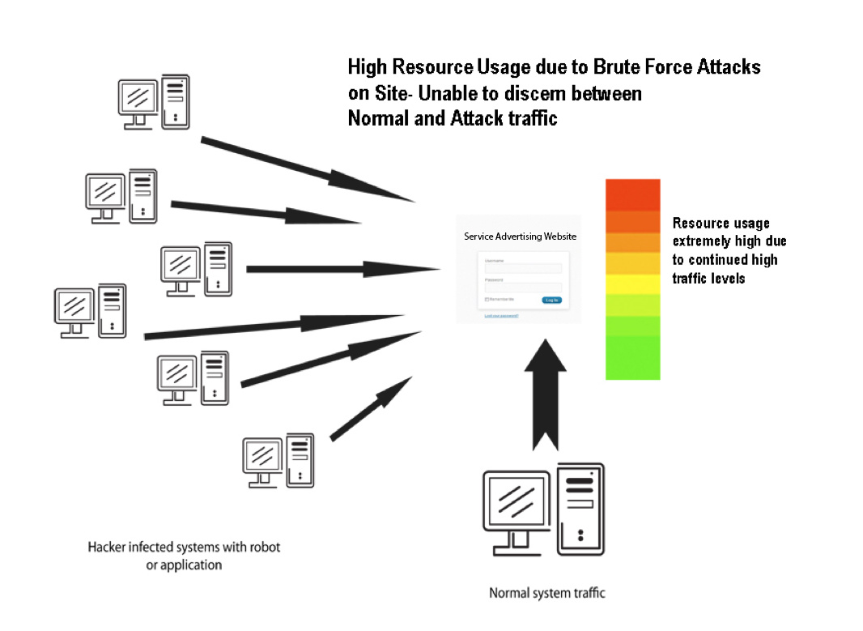

## CSRF – Cross Site Request Forgery

Each CRUD request (except for Read) will have a token to ensure the protection from CSRF and that the request is from inside our server.

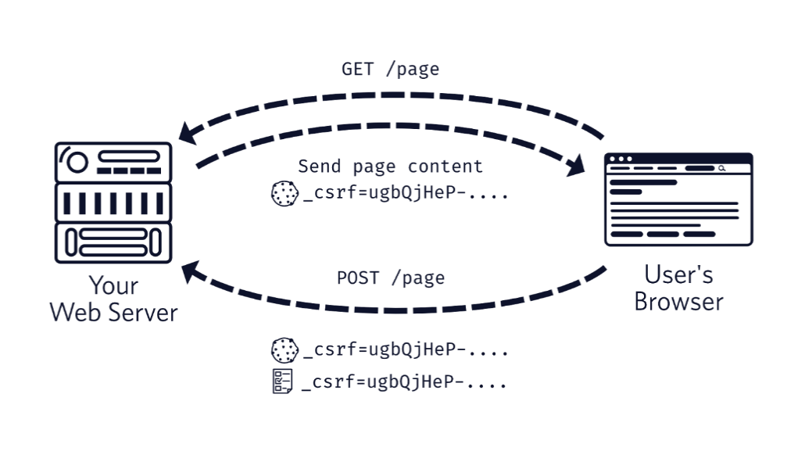

## SQL Injection

Each CRUD request (except for Read) will have check for SQL queries injected inside user’s data, and prevent this totally. 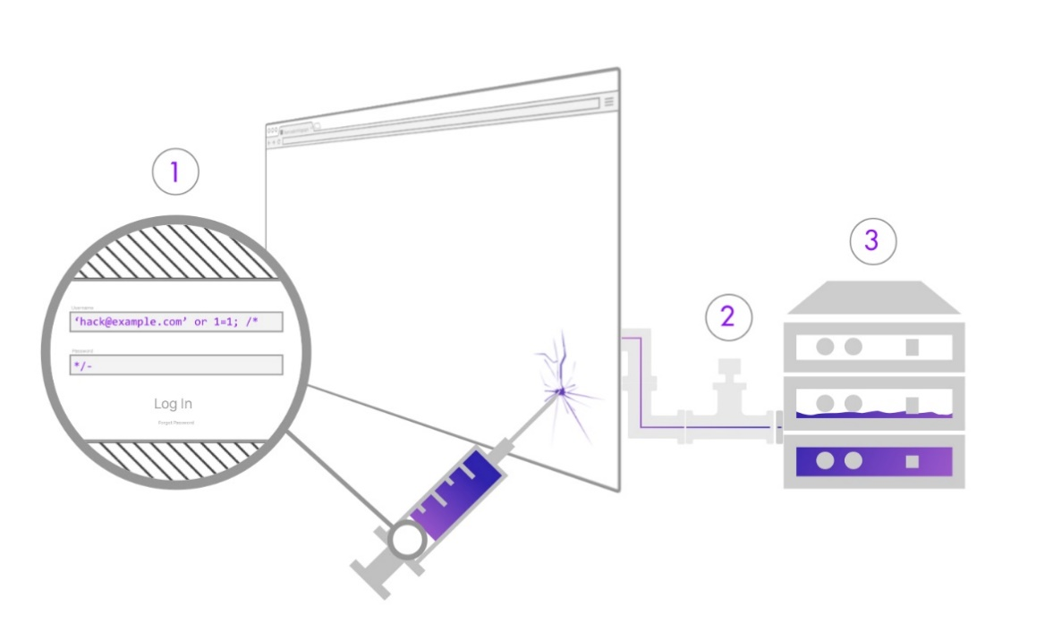

## **Reliability**

Reliability defines how likely it is for the software to work without failure for a given period of time. Reliability decreases because of bugs in the code, hardware failures, or problems with other system components. To measure software reliability, you can count the percentage of operations that are completed correctly or track the average period of time the system runs before failing.

Example: The database update process must roll back all related updates when any update fails.

## **Performance**

Performance is a quality attribute that describes the responsiveness of the system to various user interactions with it. Poor performance leads to negative user experience. It also jeopardizes system safety when it’s is overloaded.

The performance of the whole system aims to ensure ease of comfort to have the site load within five (5) seconds. This is to allow the user to be more productive within the given time they have during their working hours and as well as entering new data can easily be done without waiting. On the other hand developers, need to account for at least 174 users simultaneous because they must consider who will be using it at anyone time. This amount was discussion by the client. The priority of the performance is semi-low because as you develop the system, the focus will be come from design of the system and the coding of the system. Performance of the system will come once everything else of the system has been finalized.

Example: The front-page load time must be no more that 2 seconds for users that access the website using an LTE mobile connection.

## **Availability**

Availability is gauged by the period of time that the system’s functionality and services are available for use with all operations. So, scheduled maintenance periods directly influence this parameter. And it’s important to define how the impact of maintenance can be minimized. When writing the availability requirements, the team has to define the most critical components of the system that must be available at all time. You should also prepare user notifications in case the system or one of its parts becomes unavailable. The reason why the system has to be up from 9am-5pm is because these are the working hours of the national parks, as discussed with the client. We therefore need to schedule any maintenance tasks around this time to ensure maximum uptime for its users.

Availability is a moderate priority because the system will be required to functioning to allow operations to be done during the working hours of the business.

Example: New module deployment musn’t impact front page, product pages, and check out pages availability and mustn’t take longer than one hour. The rest of the pages that may experience problems must display a notification with a timer showing when the system is going to be up again.

## **Scalability**

Scalability requirements describe how the system must grow without negative influence on its performance. This means serving more users, processing more data, and doing more transactions. Scalability has both hardware and software implications. For instance, you can increase scalability by adding memory, servers, or disk space. On the other hand, you can compress data, use optimizing algorithms, etc.

Example: The website attendancy limit must be scalable enough to support 200,000 users at a time.

## **Modifiability**

The modifiability of the system will be modeled with Model View Controller (MVC). This will allow maintainability and more structural means for a developer to easily make changes to the system when it is required. It is a high priority because the system needs to able to easily maintainability if the original developer leaves or is unavailable to make changes to the system. As well as this it is important that the code of the system is easy to understand and readable.

## **Testability**

The reason that system will need to be able to be testable, is to ensure that the system aligns to the requirements of what is being developed by the client and furthermore to be able to provide a way for testers to show it reaches those requirements outline in the specifications of the clients. This is adequate priority for the system because the system needs to be created first before anything else to prove if the system passes on all known requirements brought up by the client.

## **Operability**

 is the ability to keep an equipment, a [system](https://en.wikipedia.org/wiki/System) or a whole industrial installation in a safe and reliable functioning condition, according to pre-defined operational requirements.

## **Development**

ProgrammingThe first skill one needs to master for being a web developer is programming. Many languages exist for different aims, but you need to know at least a few of them to be able to code a website. You can choose the ones you like by simplicity or complexity of learning, the universal use, the web development standards, the trends, recommendations, etc. For example, **HTML** **, CSS, JavaScript, PHP, SQL…etc.**

Basic Knowledge of DesignA developer is not the same as a designer, but design skills are useful and helpful to developers in their everyday work, and awareness of development is helpful for a designer. Developers should learn a bit of **graphic design**, because this can bring him a good awareness of many graphic tools which are useful for better development. When developers learn design techniques, they get a better understanding of website appeal and acquire better design taste. Taste is essential for every creative artist.

## Technology

**HTML** is the standardized markup language to create documents on the web, in other words to format the content on the webpage. This includes titles, headings, text and links. It is the most common and basic language used in website development.  
**CSS**, which means Cascading Style Sheets, is a language paired with HTML to allow a programmer to set the webpage style. Here we mean layout, colors, and fonts. These elements are kept separate from the main webpage code.  
**JavaScript** is the solution for animation, games, apps, and interactivity on a website. All dynamic effects on a site are created via this programming language.

## These languages were for the front end of website now we will see the back end part will do by: PHP is a server scripting language, and a powerful tool for making dynamic and interactive Web pages.PHP is a widely-used, free, and efficient alternative to competitors such as Microsoft's ASP. SQL is a standard language for storing, manipulating and retrieving data in databases.

**Delivery**

1. IMAGESThe most important item needed to build an impressive site all starts with the images provided. The more images you provide, the more creative we can be. Please make sure the images are all hires (1MB or higher preferred), and jpeg or tiff format.

2. WISHLISTIt's important that we accurately design your vision, which is it very important to provide a detailed idea and concept of the certain items i.e. navigation items (bio, contact etc), as well as other sample sites that you can provide as an example.

3. COPYPlease provide detailed and spell-checked copy i.e. your bio, contact information etc. We do not write or create content.

## **Legal**

* company name,address.
* developer name,number.
* contact details, including an email address.
* **…**

# **System Interfaces**

# **User Interface**

# Home page

# Login page

# Registration page

# Company profile page

Company profile shows all related information to the company i.e. name, logo, mission, vision, brief description about the company, needed positions, job requirements and selection phases for recruiting developers.

# Developer profile page

Developer profile shows all related information to the developer i.e. name, country, age, years of experience, fields of expertise, skills, programming languages mastered, working hours, payment per hour, availability and contact methods preferred.

# Administrator

Administrator can view all reporting issues from customers so he can handle it and then can contact system customers through scheduled emails contain latest issues solution, latest news, features and recommendation.

# **Communication Interface**

Our system is a standalone system that doesn’t depend on any communication to other systems or devices.